Human Observational Study Protocol

Title of Protocol: DS Biome- Down Syndrome Gut Microbiome Sibling Study

Study Number: APC147

Chief Investigator: Signature Date:
Prof Paul Cotter 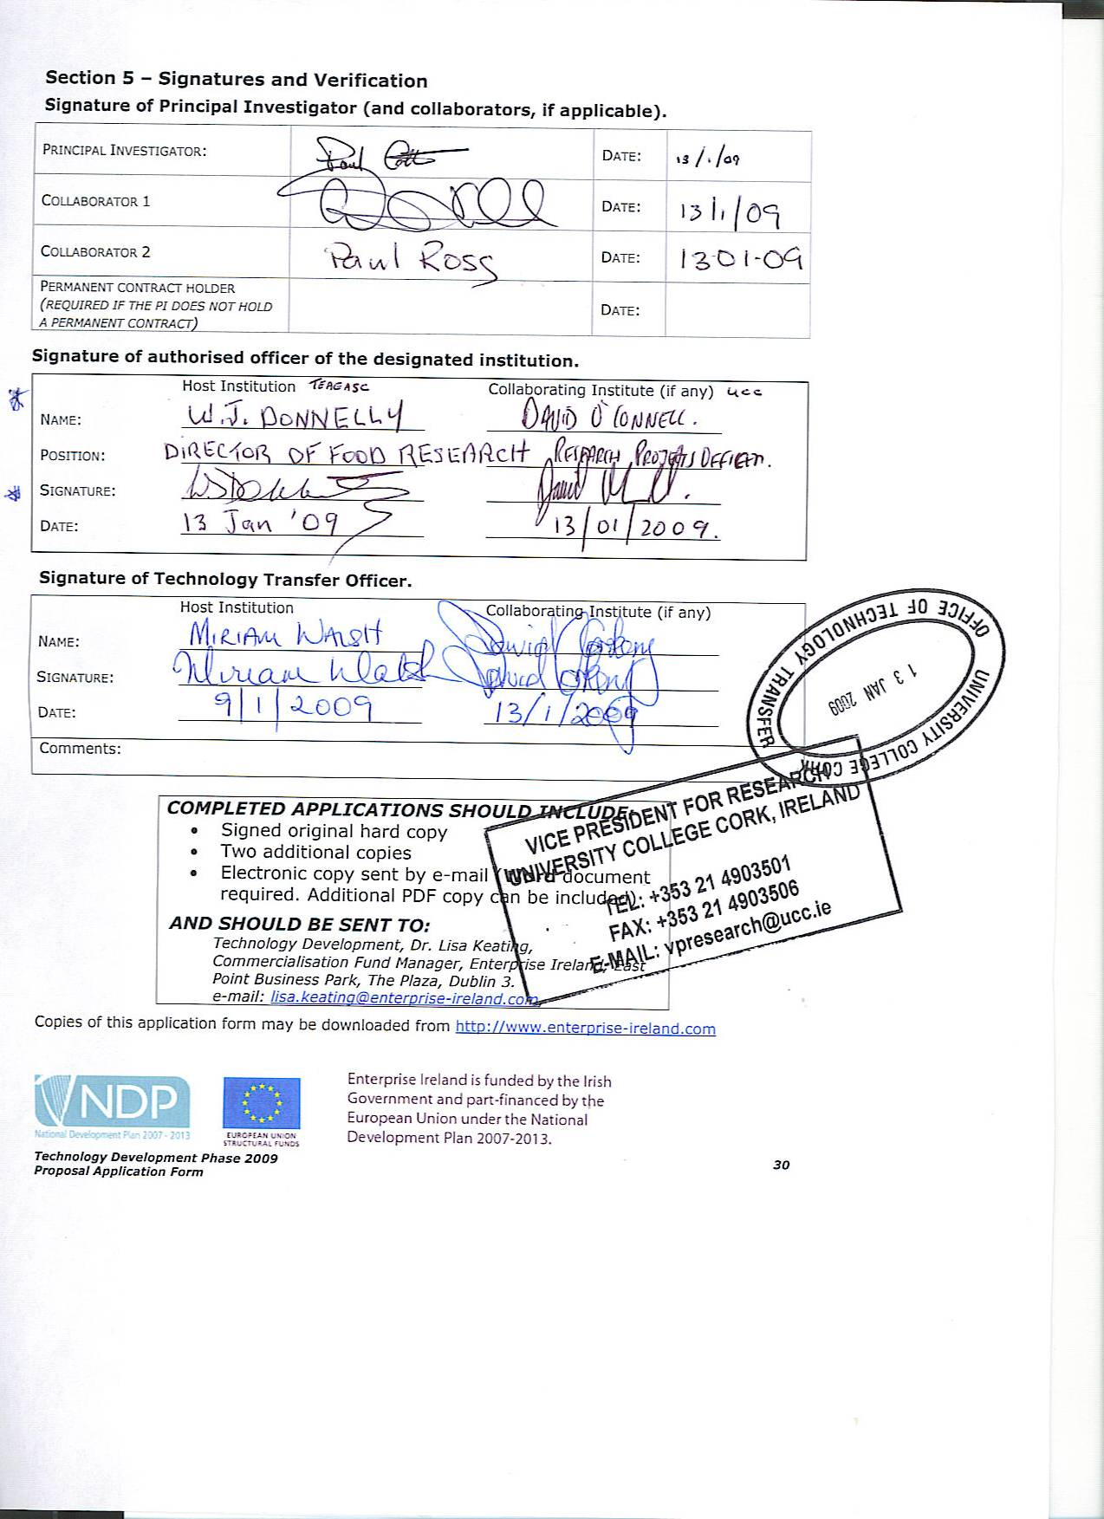 07/02/2024

Contact: paul.cotter@teagasc.ie

Co-Investigators:
Prof Fergus Shanahan
Dr Aonghus Lavelle
Dr Beatriz Gomez Sala
Ms Therese McNamee

Authors
Prof Fergus Shanahan
Prof Paul Cotter
Therese McNamee
Michelle Nugent

Sites of Investigation
Online study recruiting nationally throughout Ireland & United Kingdom.

Sites of Laboratory
Teagasc Food Research Centre, Moorepark, Fermoy, Co. Cork &
APC Microbiome Ireland, University College Cork

1. Title of Protocol
DS Biome - Down Syndrome Gut Microbiome Sibling Study

2. Study Rationale
The microbiome is a collective term for the bacteria, viruses and fungi living in and on the human body, most of which are in the gut. The microbiome is considered to be a major factor in the maintenance of health and protection against disease. In some susceptible individuals, the microbiome may contribute to the pathogenesis of certain chronic disorders. There is a paucity of information on the microbiome and Down Syndrome (DS). Aspects of DS which may be particularly influenced by the microbiome include: (a) digestive sensitivity and bowel disorders; and (b) accelerated ageing and ageing-associated disorders. In particular, an unhealthy microbiome (defined as a loss of protective microbes and gain of disease-associated microbes) has been linked with frailty, sarcopenia, cancer and inflammation. DS is associated with accelerated ageing but its relationship to the microbiome has received little attention.

3. Objectives
3.1 Primary Objective
The present proposal is to study the microbiome of DS in relation to the following questions: a) are there identifiable microbial biomarkers of digestive symptoms and of ageing in DS;

3.2 Secondary Objective
and b) could these microbiome alterations be an opportunity for targeting therapeutic intervention with diet or replacement with live biotherapeutics.

4. Safety
There is no risk with providing a stool sample. Regarding data safety, all conventional precautions will be maintained in compliance with General Data Protection Regulation (GDPR). More detials in sections 14 and 15.

5. Study Design
  - Synopsis of Study
This is a cross-sectional, observational study, designed to be completed online. We will compare older and younger people with DS relative to matched controls with out DS, including, where possible, from siblings (or a parent) to control for environmental factors. A faecal sample will be provided by participants and subjected to microbiome analysis. Gut microbiota data will be correlated with other personal information relating to health and ageing to identify microbial biomarkers and microbial populations that may contribute to/protect against premature ageing and digestive disorders.

  - Study participation and recruitment of subjects
Persons with DS (any sex or age) and either a sibling or parent of the participant with DS (also any sex or age) will be recruited to the study.

Participants will be recruited through the online membership of Down Syndrome Ireland and the Down Syndrome Centre and through other appropriate channels such as UCC and Teagasc email lists, along with suitable forms of social media. We will also recruit from the UK as this is an online study and we have an established network for recruitment via NHS and Down Syndrome Education International (UK branch). Electronic study advertisements will be used to advertise through these methods. Hard copies of these advertisements will also be erected in suitable sites. An electronic social story may be used as a form of advertisement for the study or may be provided as a complement to the participant information leaflet / consent/assent forms to give potential participants an idea of what to expect within the study if they decide to take part. We aim to recruit at least 100 participants in our study.

Study participation will involve the participant with DS and if possible, either their sibling (or parent) providing a stool sample, answering some general health questions and completing the following;
- a food frequency questionnaire
- 3 day food diary for those 6 years and younger via Intake 24 (instructions provided)
- and the Bristol Stool Scale at the time of donating the sample

Consent/assent forms / parental permission / data protection notice
Only participants who can provide informed consent/assent will be included in this study. Interested participants will complete an online consent/assent form, located on the Teagasc website. Parent/guardian permission will also be obtained online for minors. A data protection notice detailing what will happen to participants personal data and samples will also be included within the consent form and completion of a tick box will be required to confirm acknowledgement of this. An electronic copy of the consent/assent form including the data protection notice will be emailed to participants or their parents/guardians. A unique ID number will be generated by the researcher at this point for each of the participants and will later be affixed to sample kits and also aligned to questionnaire access. Participation involves three steps;

STEP 1: Diet and health questionnaires
Once the participant has consented (and or parent/guardian, if applicable), participants will have online access to a form containing the dietary and health questionnaires. Both the participant with DS and the sibling (or parent) will each complete two online questionnaires, one health related and the other diet related (with the support of a family member or guardian where necessary). If further assistance is required to complete these online forms, study participants may contact a registered nurse for intellectual disability (part of the study team), who will assist them with the process and answer any questions they may have.

STEP 2: Provide a stool sample
Participants will be requested to provide a stool sample, using an at-home stool sample collection kit, mailed to the participant's home. Samples will be posted back for analysis (using pre-paid envelopes), to the Paul Cotter Lab, Vision 1, at Teagasc Food Research Centre, Moorepark, Fermoy, Co. Cork. Participants will be provided with easy-to-follow instructions on how to provide a stool sample for the study.

STEP 3: Complete the Bristol Stool Chart
Print outs of the Bristol stool charts will also be provided in the envelopes containing the stool collection kits and participants / parents/guardians will be required to complete them based on the stool sample at time of collection.

6. Inclusion and Exclusion Criteria
6.1 Inclusion Criteria:
Participants with DS
Other than having DS, there is no further criteria for inclusion. Our study will accept both male and female participants, of any age.

Matched controls (sibling or parent)
We will also include siblings of participants with DS, as matched controls, when possible. Our study will accept both male and female siblings, of any age. In the absence of a sibling, we will also accept a parent as a control, again of any age or gender. In the absence of a matched control, we will still welcome the participation of the individual with DS into the study by themselves.

6.2 Exclusion criteria
Participants with DS
Likewise, there are no exclusion criteria. If the participant is on medication or has recently taken an antibiotic or has a co-existing condition, we would need to obtain this information. Our linked health questionnaire, which includes questions on medication, antibiotics or co-existing conditions, will provide an opportunity to capture this data.

Matched controls (sibling or parent)
There are no other exclusion criteria. If the sibling or parent is on medication or has recently taken an antibiotic or has a co-existing condition, we would need to obtain this information also. Our linked health questionnaire will provide an opportunity to capture this data.

7. Study Procedures
The study will be conducted as outlined in this protocol and as appropriate, in accordance with the International Conference on Harmonization (ICH) Guidelines on Good Clinical Practice and the Declaration of Helsinki.

  - Study visits:
No study visit will be necessary, as the study has been designed as an online study.
  - Removal of participants from the study
Participants will be withdrawn from the study if the participant elects independently to withdraw from the study. If participants withdraw their samples may still be used in the study unless they specifically ask for their samples to be removed.

7.3 Concomitant Medication
Participants will be questioned about their medication history. The details of any medication taken will be recorded in the participant’s health questionnaire.

8. Biological Sample Collections and Analysis
8.1 Stool collection
Participants will be requested to provide a stool sample, using an at-home stool sample collection kit, posted to participant's homes. The samples will be in biopreservation tubes which will allow them to be stored at room temperature. Samples will be posted back for analysis (using pre-paid envelopes), to the Paul Cotter Lab, Vision 1, at Teagasc Food Research Centre, Moorepark, Fermoy, Co. Cork. Participants will be provided with easy-to-follow instructions for sample collection.

8.2 Stool analysis
Stool samples will be analysed in the first instance in the Paul Cotter Lab, Vision 1, at Teagasc Food Research Centre, Moorepark, Fermoy, Co. Cork and provided no other detailed equipment is required, that’s all that will be necessary. Samples will be subjected to microbiome analysis such as DNA extractions, PCR, sequencing and bioinformatics. Participants will be informed that they are giving us the right to use their faecal sample for research and this may involve collaborating with a 3rd party such as another academic centre, and other academic scientists, including those involved in industry.

9. Changes in the conduct of the study or planned analyses
With the exception of emergencies, any significant change in the protocol (i.e. one that affects the safety of the participants, scope of the investigation, the scientific quality of the study) will not be implemented until the Clinical Research Ethics Committee (CREC) have reviewed, approved, and documented the protocol amendment in writing. Amendments include changes to the investigator/investigators and/or site address, etc. When a change is made to eliminate or reduce the risk to participants, it may be implemented before review and approval by CREC. The investigator shall notify CREC of said change in writing within 5 working days after implementation.

As this is an online observational study, with no invasive procedures, no emergency medical events are foreseen. Minor or non-significant changes (e.g. change to statistician, typographical errors, spelling errors, etc) will not be made until said change is reviewed and approved by the Clinical Research Ethics Committee and an approval letter is provided to the study Chief investigator.

10. Obligation of the investigator
The study will be conducted in accordance with the appropriate ethical principles set out in the Declaration of Helsinki, the International Conference on Harmonisation Good Clinical Practice (ICH-GCP) and all applicable local regulatory requirements.

The study Chief Investigator and co-investigators will perform or directly supervise the performance of all described procedures in accordance with the highest standards of medical and clinical research practice. Delegation of any study responsibility will be documented in writing in the delegation log. It is the responsibility of the Chief Investigator and any co-investigator to understand and follow the protocol and to ensure that all the members of the assisting research staff also understand and follow the protocol.

11. Advertising
Any advertisements for participants, whether in professional or consumer publications, radio, television, flyer, poster, Tweet(s), Facebook Post(s), LinkedIn Post(s), Instagram Post(s), Email, Audiogram Script, Video Script, Blog Post, Web Page, Press Release, Photo Captions will be approved by the Clinical Research Ethics Committee prior to initiation.

12. Institutional review
The sites, investigators, protocol, informed consent form/assent form, parental permission form and any other pertinent documents for this study will be approved by: Clinical Research Ethics Committee of the Cork Teaching Hospitals, Lancaster Hall, 6 Little Hanover Street, Cork. The study will not begin until CREC has approved of the protocol and the participant information leaflet and consent/assent form and parental permission form along with any advertisements, diaries and instructions to the participants, if applicable. CREC approval will be documented in writing to the investigator.

13. Participant Consent
Clinical Research Ethics Committee approval of informed consent/assent form will be obtained prior to its use. This consent/assent form will comply with all the regulations governing the protection of human participants. Each potential participant, or participant’s guardian, will complete an online informed consent/assent form to serve as a participant in the study. A completed copy of the consent/assent form will be emailed to the participant or the participant’s parent/guardian and a completed copy will be retained by the investigator in the participant’s electronic study file.

Participants may withdraw from this study at any time without detriment. Data and stool samples already collected prior to withdrawal may still be used in the study. If a participant explicitly requests however for their collected data/samples to be removed from the study then they will be removed, provided the data/samples have not already been analysed.

14. Data Collection
The investigator is responsible for ensuring that all online data collected, posted stool sample and paper Bristol stool chart are maintained according to the study protocol, and relevant Good Clinical Practice (GCP) and are available from the study Chief Investigator. All data entered onto the online questionnaires or provided at time of sample collection (Bristol Stool Chart) will be identified only by a unique identification code. Unique identification codes will be assigned by the researcher after informed consent/assent has been obtained. The unique identification code will be written on the participants stool collection tubes and Bristol stool charts when they receive them in the post. When they receive the online health questionnaire and food frequency questionnaire the participants unique identification code will be written on this also.

15. Confidentiality
All conventional precautions will be maintained in compliance with General Data Protection Regulation (GDPR). In addition, the identity of all participants’ samples and study records will be coded and computer databases will adopt unique identification codes rather than participant names. In addition, computer access will require an entry code. Each participant / parent/guardian will have to acknowledge the Teagasc data protection notice relating to their rights and the protection of their data/samples.

16. Funding of trial
This study is being funded by a research grant from the Jérôme Lejeune Foundation, along with a small grant from APC Microbiome Ireland. There are no cost implications for the participants.

17. Insurance policy
This study involves exclusively the faculty or affiliates of University College Cork. Other than University Sponsored liability coverage for human research, there are no other arrangements for insurance coverage.

